GROUP 15
Members
- Kyle Aluma – 220738
- Arnold Nyasimi- 221816
- Alvin Baraka- 177155
- Vincent Gikuyu- 196135

Course Analytics System - Technical Documentation

Overview
The Course Analytics System is a Java-based desktop application designed to analyze student engagement and course performance data. The system processes CSV data files, stores information in a MySQL database, and provides statistical analysis with interactive visualizations.

Database Schema

Tables
- students Table Purpose: Stores student demographic information Schema:
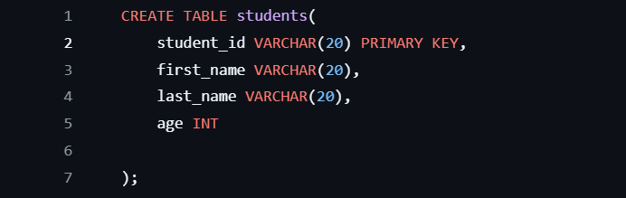

Columns:
student_id: Unique identifier for each student
first_name: Student’s first name
last_name: Student’s last name
age: Student’s age
- Student Activity
Table Purpose: Tracks student engagement metrics across courses Schema:
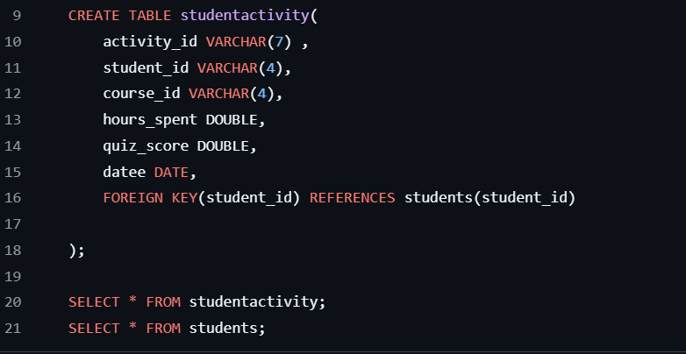

Columns: - activity_id: Unique identifier for each activity record

student_id: Reference to student (foreign key)

course_id: Course identifier

hours_spent: Hours spent on course activity

quiz_score: Quiz score achieved (0-100)
datee: Date of the activity

Data Models
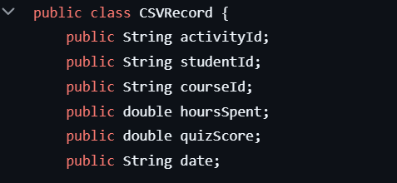

Purpose: Represents a single row from activity CSV files with engagement metrics.

Core Queries and Analysis
- Average Quiz Score by CourseQuery:
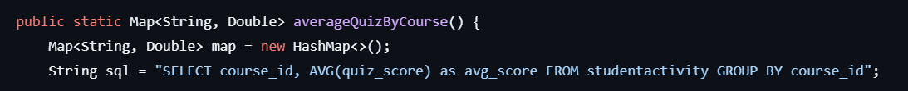

Results: Returns Map<String, Double> where: - Key: Course ID - Value: Average quiz score for that course
Insights: Identifies courses with higher/lower performance levels, helping pinpoint curriculum effectiveness.

This is a graph showing course against Average quiz score.
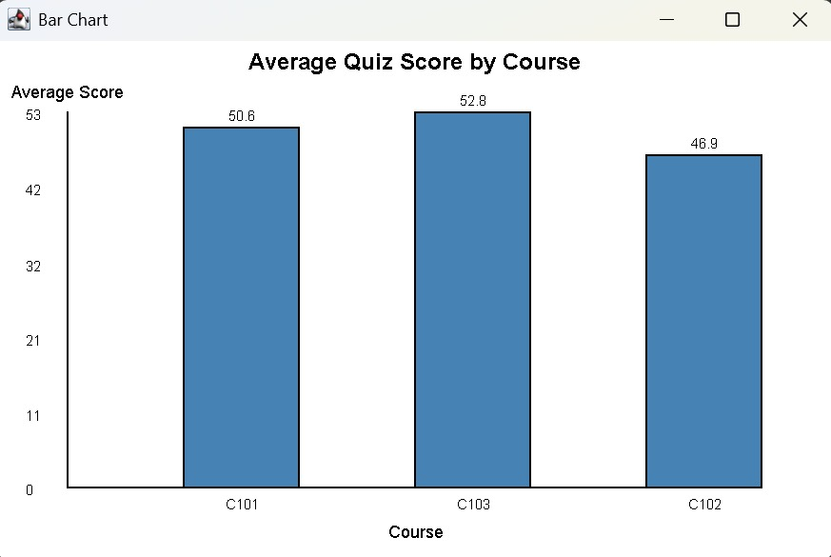

- Hours vs Score Correlation AnalysisQuery:
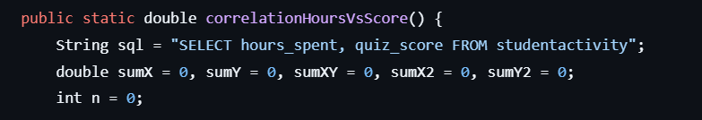

Results: Returns correlation coefficient (-1 to +1) - Positive: More study hours correlate with better scores - Negative: More hours correlate with lower scores
(possible burnout) - Near zero: No significant correlation
Insights: Reveals study effectiveness patterns and optimal study time ranges.

This is a graph of Hours studies against quiz score:
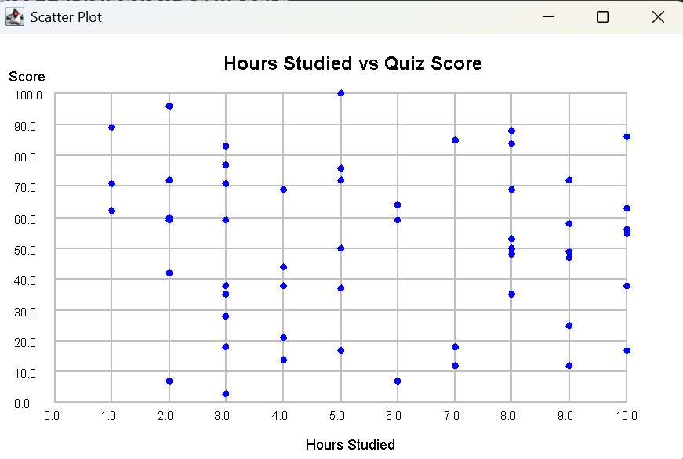

- Total Hours Per StudentQuery:
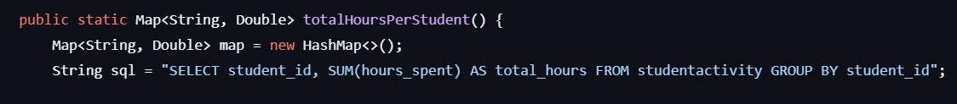
Results: Returns Map<String, Double> mapping student IDs to total study hours.
Insights: Identifies most engaged students and helps detect study patterns.

- Student Engagement ClassificationQuery:
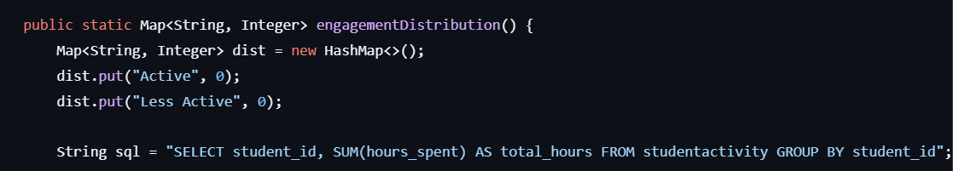

Classification Logic: - Active: 10 total hours - Less Active: < 10 total hours
Results: - Distribution map: Map<String, Integer> with engagement category counts - Individual classification: Map<String, String> with student classifications
Insights: Provides quick overview of class engagement levels and identifies atrisk students.

Data Import Process

CSV File Formats Supported Activity Data Format
activity_id,student_id,course_id,hours_spent,quiz_score,datee
ACT001,STUD001,COURSE101,5.5,85.0,2024-01-15
ACT002,STUD001,COURSE101,3.2,78.5,2024-01-16

Student Data Format
student_id,first_name,last_name,age
STUD001,John,Doe,20
STUD002,Jane,Smith,21

CSV Loading Process
- File Validation: Checks header format and column names
- BOM Handling: Removes UTF-8 BOM if present
- Data Type Validation: Ensures numeric fields parse correctly
- Error Handling: Skips malformed rows with logging
- Database Insertion: Uses prepared statements for safety

Key Components

1. Database Connection (DBConnection.java)
- Purpose: Centralized database connection management
- Configuration: Loads from db.properties file
- Features: Connection pooling, error handling

2. Data Access Objects
- StudentDAO.java: Handles student data operations
- ActivityDAO.java: Manages activity data insertion
- Features: Duplicate prevention, transaction safety

3. Analysis Engine
i) StatsHelper.java: Core statistical calculations
ii) EngagementAnalysis.java: Student classification logic
- Features: Memory-efficient processing, error resilience

4. User Interface
- LoginDialog.java: Authentication interface
- MainWindow.java: Main application dashboard
- StatsViewer.java: Results visualization

Configuration Files db.properties
db.url=jdbc:mysql://localhost:3306/student_schema
db.user=root db.password=Kyle@123
users.properties
# Login credentials (username=password) group15=Devgroup_15

Challenges and Solutions

1. CSV Data Inconsistency
Challenge: Variations in CSV column names and formats Solution: - Flexible header validation with case-insensitive matching - Support for both “date” and “datee” column names - BOM removal for UTF-8 files - Row-by-row error handling with skip functionality

2. Database Connection Management
Challenge: Connection leaks and configuration security
Solution: - Centralized connection management in DBConnection - External configuration files excluded from version control - Prepared statements to prevent SQL injection Automatic resource cleanup with try-with-resources

3. Statistical Calculation Accuracy
Challenge: Handling edge cases in correlation calculations
Solution: - Division by zero protection in correlation formula - Proper handling of empty datasets - Floating-point precision management - Null safety in database queries

4. Performance Optimization
Challenge: Large dataset processing efficiency Solution: - Streaming CSV processing (line-by-line) - Database-level aggregation with GROUP BY - Memoryconscious data structures (HashMaps) - Batch processing for database inserts

5. Data Validation and Error Handling
Challenge: Malformed data and missing values Solution: - Comprehensive CSV format validation - Try-catch blocks around parsing operations - Graceful degradation (skip bad rows, continue processing) - Detailed error logging for debugging

6. User Authentication Security
Challenge: Secure credential management Solution: - Properties file for credentials (excluded from git) - Simple but effective authentication mechanism Login dialog prevents unauthorized access - Clear separation of authentication and application logic

Statistical Insights Provided

1. Course Performance Analysis
- Average quiz scores per course
- Course difficulty assessment
- Curriculum effectiveness measurement

2. Student Engagement Metrics
- Total study time distribution
- Engagement classification (Active/Less Active)
- Individual student performance tracking

3. Correlation Analysis
- Study time vs. performance relationship
- Identification of optimal study patterns
- Detection of potential burnout scenarios

4. Trend Analysis
- Performance patterns over time
- Engagement level changes
- Course comparison metrics

Technical Architecture

Layer Structure

Presentation Layer
(GUI Components: Login, Main,
Stats Viewer, Visualizations)

Business Logic Layer
(Analysis Engine, Stats Helper,
Engagement Analysis)

Data Access Layer
(DAOs: Student, Activity, CSV
Loader, DB Connection)

Data Storage Layer
(MySQL Database: students,
studentactivity tables)

Design Patterns Used
- DAO Pattern: Separation of data access logic
- Factory Pattern: Database connection creation
- Observer Pattern: GUI event handling
- Strategy Pattern: Different analysis algorithms

Performance Considerations

Database Optimization
- Indexed primary keys for fast lookups
- Foreign key constraints for data integrity
- Aggregate queries for efficient statistics

Memory Management
- Streaming CSV processing to avoid memory overload
- HashMap usage for O(1) data access
- Proper resource cleanup with try-with-resources

Scalability
- Modular design allows easy addition of new analysis methods
- Database-centric approach supports large datasets
- Configurable thresholds for engagement classification

Future Enhancement Opportunities

1. Advanced Analytics
- Time series analysis for performance trends
- Predictive modeling for student success
- Machine learning integration for pattern recognition

2. Enhanced Visualizations
- Interactive charts with drill-down capabilities
- Heat maps for course engagement
- Real-time performance dashboards

3. Data Import Improvements
- Support for additional file formats (Excel, JSON)
- Automated data validation and cleaning
- Bulk import capabilities with progress tracking

4. Security Enhancements
- Role-based access control
- Audit logging for data changes
- Encrypted credential storage

Conclusion
The Course Analytics System provides a robust foundation for student engagement analysis with well-structured data models, efficient query processing, and comprehensive error handling. The modular architecture allows for future enhancements while maintaining code quality and performance standards.
The system successfully addresses common data analysis challenges through careful design decisions, including flexible CSV processing, secure database operations, and accurate statistical calculations. The engagement classification system provides immediate value for identifying student performance patterns and at-risk individuals.

